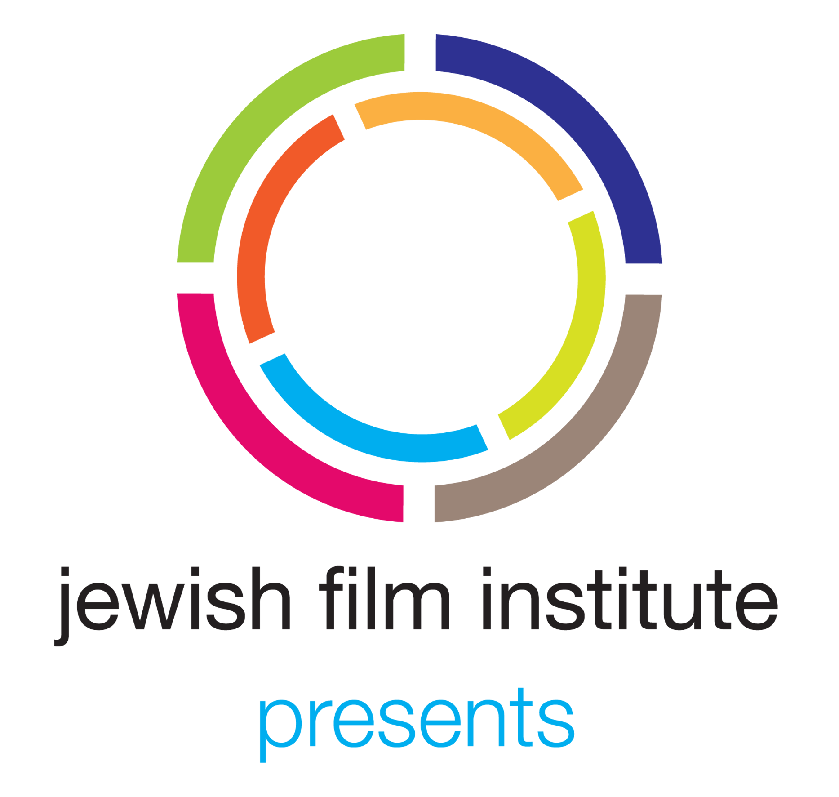 | 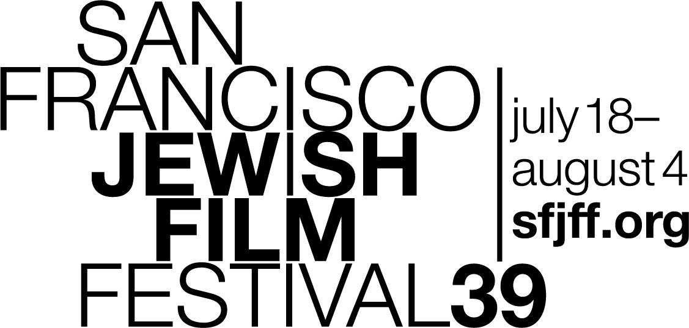 | FOR IMMEDIATE RELEASE  Media contact: Larsen Associates at (415) 957-1205 or publicity@larsenassc.com  This is not the public information  number. Please do not publish it.

BAY AREA PREMIERE OF “WHAT SHE SAID: THE ART OF PAULINE KAEL” TO HIGHLIGHT LOCAL FILMS AND FILMMAKERS AT THE 39TH SAN FRANCISCO JEWISH FILM FESTIVAL

SAN FRANCISCO, May 30, 2019 - The 39th San Francisco Jewish Film Festival, presented by the Jewish Film Institute, will showcase another strong array of local films and filmmakers from the Bay Area highlighted by the Bay Area Premiere of Rob Garver’s WHAT SHE SAID: THE ART OF PAULINE KAEL as the festival Local Spotlight. The festival returns to the Bay Area July 18th to August 4th.

Local Spotlight - WHAT SHE SAID: THE ART OF PAULINE KAEL

WHAT SHE SAID: THE ART OF PAULINE KAEL
Directed by Rob Garver
This new documentary centers around one of the most powerful, and personal, movie critics of the 20th century. Pauline Kael broadcast many of her early reviews on KPFA in Berkeley, and programmed the legendary Berkeley Cinema Guild theater from 1955 to 1960. Writing for The New Yorker and publishing a dozen best-selling books, she ruthlessly pursued what exactly made a movie or an actor’s performance work, or not, and why. Her passion made this Jewish Bay Area native - from a Petaluma chicken farm, to UC Berkeley and San Francisco - both admired and despised amongst her readers. Kael’s voiceover in the film is performed by Sarah Jessica Parker.
Pauline Kael lived in San Francisco, Berkeley, and Petaluma. Other people with local connections featured in the film include writers Greil Marcus & Dirk van Vouhuys, Ortrun Niesar of Sotheby’s (who handled the sale of Kael’s former home with its historic murals by San Francisco artist Jess), and former longtime SF Examiner film critic Michael Sragow.

Other Films with Local Connections
SAN FRANCISCO

Fillmore
JERUSALEM_IN_BETWEEN
Directed by Pietro Pinto
Two boxers, one Jewish and one Arab, share their life story and their similarities.
Director Pietro Pinto lives in the Fillmore District.

Outer Richmond
GUY HIRCEFELD, A GUY WITH A CAMERA
Directed by Andrés Gallegos
A veteran who served in the Israeli military, Guy Hircefeld now fights against the Israeli occupation and environmental warfare with his only weapon, a camera.
Director Andrés Gallegos lives in the Outer Richmond.

Sunset
PETTING ZOO
Directed by Daniel Robin
PETTING ZOO is a narrative about the formation of American Jewish identity, and transforms into an analogy for the current rise in nationalism and anti-Semitism in America and the world.
Director Daniel Robin is a SF State Alum, located in the Sunset.

Various SF Neighborhoods
SEDER-MASOCHISM
Directed by Nina Paley
Nina Paley’s (SITA SINGS THE BLUES) animated musical retelling of the Exodus and Passover is beautifully crafted, highly entertaining and delightfully provocative. Think FANTASIA meets the Old Testament, coupled with serious feminist criticism and a rocking soundtrack. Paley’s syncopated, beat-driven scenes of the ten plagues are exceptionally drawn.
Director Nina Paley lived in San Francisco from 1981 to 2002 (Castro, Haight, Mission, and Noe Valley).

BERKELEY

ADAM
Directed by Rhys Ernst
Directed by Transparent producer Rhys Ernst and adapted by Ariel Schrag from her novel of the same name, ADAM drops us down in Brooklyn’s queer hipster culture in the era of The L Word. This poignant directorial debut is a coming-of-age story about a 17-year-old cisgender high schooler who falls in love with his sister’s lesbian friend after she mistakes him for transgender male. Adam decides to maintain this Shakespearean deception and a satirical and nuanced exploration of identity ensues.
Film producer James Schamus is a UC Berkeley Alum. Writer Ariel Schrag was born in Berkeley and attended Berkeley High School.

ADVOCATE
Directed by Rachel Leah Jones
ADVOCATE follows Israeli human-rights lawyer Lea Tsemel. Having defended Palestinians against a host of criminal charges in Israeli courts for nearly five decades, she is a staunch supporter of compassion within the court system. This documentary juxtaposes two of Tsemel’s cases: the defense of a minor accused of attempted murder and a past case in which she defended her activist husband from an accusation of treason against the state.
Director Rachel Leah Jones was born in Berkeley and lives part time in Tel Aviv.

PACIFICA

PACIFIC GROVE

PICTURE OF HIS LIFE
Directed by Yonatan Nir and Dani Menkin
Amos Nachoum is one of the greatest underwater photographers of all time. Fascinated by the most fearsome creatures on Earth, he has developed a unique approach, that puts him face to face with his subjects, without any protection. At the age of 65, he is about to face his ultimate challenge: to swim unprotected with a polar bear.
Film subject Amos Nachoum lives in Pacific Grove.

---
Entering its 39th year, the Festival is expecting an audience of over 40,000 moviegoers at the following theaters; the Castro Theatre in San Francisco, various locations in the East Bay, the CinéArts Theatre in Palo Alto, and the Christopher B. Smith Rafael Film Center in San Rafael.

For general and ticket information, visit jfi.org/sfjff and sfjff.org or email jewishfilm@sfjff.org. To contact the SFJFF Box Office directly, please email boxoffice@sfjff.org or call 415.621.0568. The full program for SFJFF39 will be revealed on June 18, 2019.

For Festival logos, photos and press materials, visit jfi.org/press or sfjff.org/press. To request interviews or screeners, contact Larsen Associates.

HASHTAGS: #SFJFF, #SFJFF39 and #SFJEWISHFILM / @sfjewishfilm
Facebook: | facebook.com/sfjewishfilm/
Twitter: | @SFJewishFilm
Instagram: | @SFJewishFilm
YouTube: | youtube.com/sfjewishfilm
Website: | www.jfi.org / www.sfjff.org

###
About the Jewish Film Institute
The Jewish Film Institute (JFI) is the premier curatorial voice for Jewish film and media and a leading arts and culture organization in the Bay Area. Presenter of the San Francisco Jewish Film Festival, JFI catalyzes and inspires communities in San Francisco and around the world to expand their understanding of Jewish life and culture through film, media, and dialogue. Year round, the Jewish Film Institute promotes awareness and appreciation of the diversity of the Jewish people through multiple mediums – including original online programming that reaches a global audience of over 2 million views. All of these services, along with artists’ support and educational initiatives, give audiences around the world even greater access to Jewish culture and the visionaries who shape it.

About the San Francisco Jewish Film Festival
The San Francisco Jewish Film Festival (SFJFF), presented by the Jewish Film Institute, is the largest and longest-running festival of its kind and a leader in the curation and presentation of new film and media exploring the complexities of Jewish life around the world. Presenting more than 65 films and 135 individual screenings, performances and events in five Bay Area cities (San Francisco, Palo Alto, San Rafael, Oakland, Albany), SFJFF attracts more than 40,000 filmgoers and industry professionals to its 18-day program.

