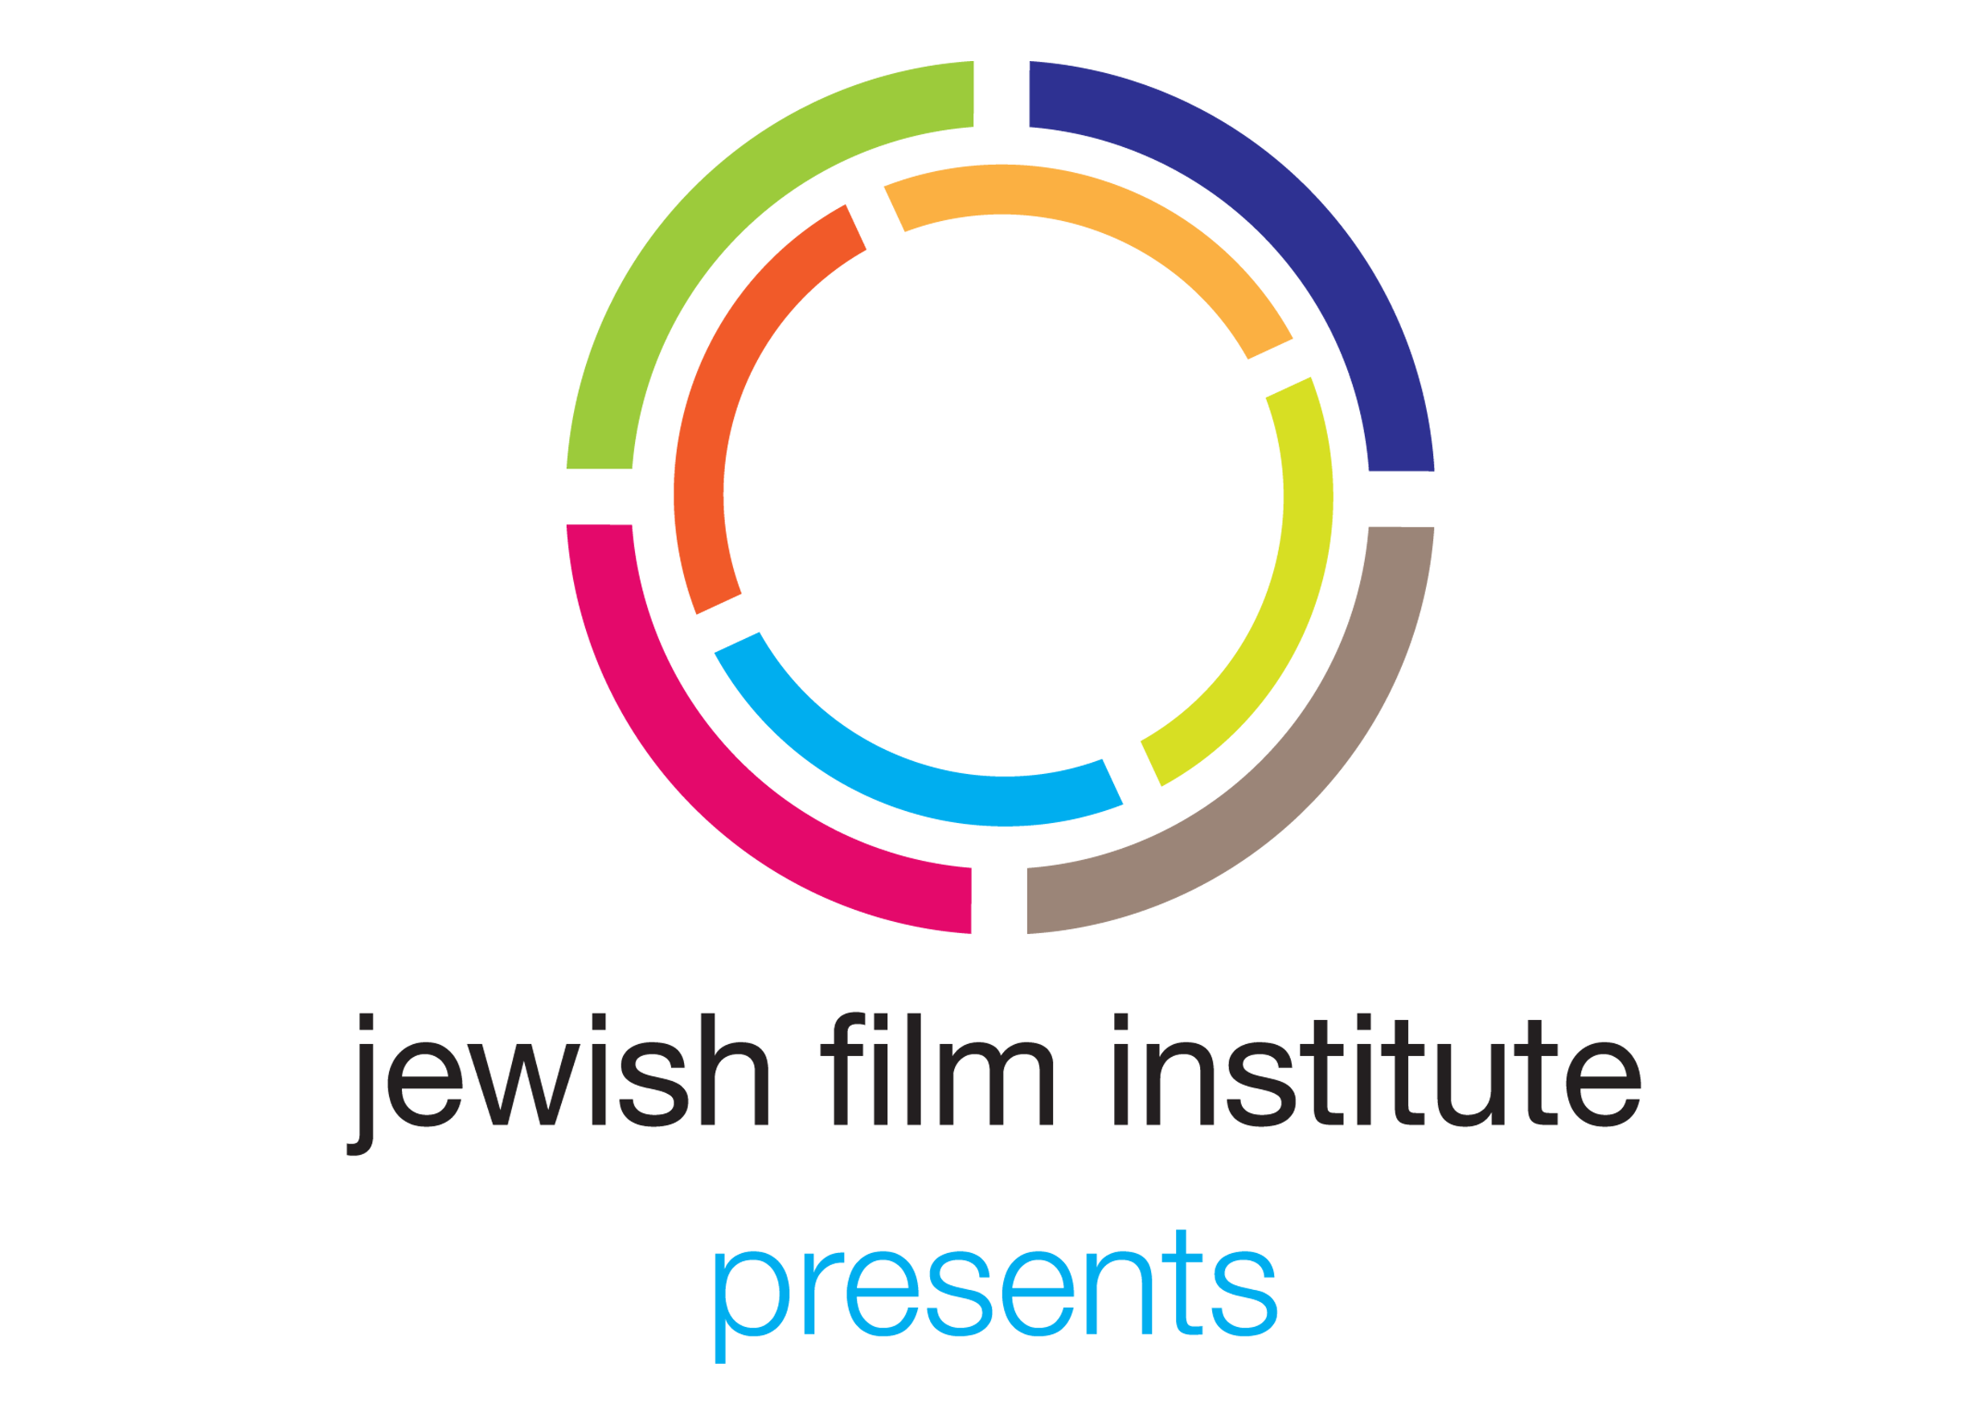 | 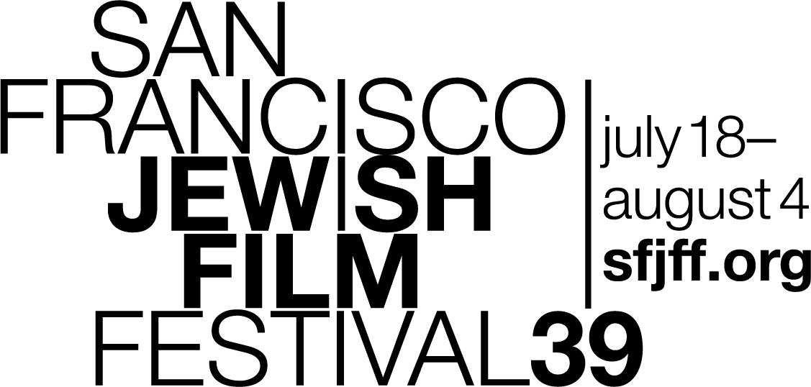 | FOR IMMEDIATE RELEASE  Media contact: Larsen Associates at (415) 957-1205 or publicity@larsenassc.com  This is not the public information  number. Please do not publish it.

39th SF JEWISH FILM FESTIVAL TO PRESENT
TAKE ACTION DAY: SOCIAL JUSTICE FILMMAKERS REPAIR THE WORLD

SAN FRANCISCO - The Jewish Film Institute (JFI) announces that the 39th San Francisco Jewish Film Festival (SFJFF) will present TAKE ACTION DAY: SOCIAL JUSTICE FILMMAKERS REPAIR THE WORLD on Monday, July 22, at the Castro Theatre in San Francisco.

SFJFF39’s annual Take Action Day is a full-day lineup of impactful documentaries exemplifying the Jewish values embodied in tikkun olam, which inspire us to repair the world with our actions. Each film will be followed by discussions with attending filmmakers and community leaders who are making a difference, led by award-winning former JFI Filmmaker in Residence Nico Opper.

This year’s programs build connections within and beyond Jewish communities and prompt us to examine our own action and inaction. American Muslim by Adam Zucker explores Muslim/Jewish alliances in the face of rising hate-based violence; Refugee Lullaby by Ronit Kertsner reveals what results when one person is compelled to act because of his family history; COOKED: Survival by Zip Code by SFJFF Freedom of Expression Award recipient Judith Helfand confronts the effects of climate change in a profoundly unequal world; and American Factory by Steven Bognar and Julia Reichert observes what happens when a Chinese billionaire opens an auto glass company in a shuttered auto factory in Ohio.

Take Action Day is facilitated by Nico Opper, an Emmy-nominated filmmaker who directed the feature documentary Off and Running. The film had a national broadcast on the PBS documentary series POV. Most recently, Opper directed and produced the The F Word: A Foster-to-Adopt Story, which was nominated for a Gotham Award for Breakthrough Series and named one of the “Best Web Series of 2018” by Indiewire Magazine.

Other films in this year’s Festival with social justice and activist themes include Advocate by Rachel Leah Jones, Afterward by Ofra Bloch, The Passengers by Ryan Porush, This is Personal by Amy Berg, and The State Against Mandela and the Others by Nicolas Champeaux and Gilles Porte.
---
For Festival logos, photos and press materials, visit jfi.org/press or sfjff.org/press. To request interviews or screeners, contact Larsen Associates at publicity@larsenassc.com or call 415.957.1205.

For general or ticket information, visit sfjff.org or email jewishfilm@sfjff.org. To contact the SFJFF Box Office, please email boxoffice@sfjff.org, or call 415.621.0523.

HASHTAGS: #SFJFF, #SFJFF39 and #SFJEWISHFILM / @sfjewishfilm
Facebook: | facebook.com/sfjewishfilm/
Twitter: | @SFJewishFilm
Instagram: | @SFJewishFilm
YouTube: | youtube.com/sfjewishfilm
Website: | www.jfi.org / www.sfjff.org

About the Jewish Film Institute
The Jewish Film Institute (JFI) is the premier curatorial voice for Jewish film and media and a leading arts and culture organization in the Bay Area. Presenter of the San Francisco Jewish Film Festival, JFI catalyzes and inspires communities in San Francisco and around the world to expand their understanding of Jewish life and culture through film, media, and dialogue. Year round, the Jewish Film Institute promotes awareness and appreciation of the diversity of the Jewish people through multiple mediums – including original online programming that reaches a global audience of over 2 million views. All of these services, along with artists’ support and educational initiatives, give audiences around the world even greater access to Jewish culture and the visionaries who shape it.

About the San Francisco Jewish Film Festival
The San Francisco Jewish Film Festival (SFJFF), presented by the Jewish Film Institute, is the largest and longest-running festival of its kind and a leader in the curation and presentation of new film and media exploring the complexities of Jewish life around the world. Presenting more than 65 films and 135 individual screenings, performances and events in five Bay Area cities (San Francisco, Palo Alto, San Rafael, Oakland, Albany), SFJFF attracts more than 40,000 filmgoers and industry professionals to its 18-day program.

